**Acceptance Test Automation for currency converter web application**

URL: <http://www.xe.com/currencyconverter/>

The automation is done using selenium java and maven in TestNG using Eclipse

**Below is the Testcase automation code to check whether the application is able to convert amount 12 from Euro to British Pounds:**

**public** **class** MavenTest1 {

**public** String baseUrl = "https://www.xe.com/currencyconverter/";

String driverPath = "C://chromedriver_win32//chromedriver.exe";

**public** WebDriver driver ;

@Test

**public** **void** test() {

// set the system property for Chrome driver

System.*setProperty*("webdriver.chrome.driver", driverPath);

// Create driver object for CHROME browser

WebDriver driver = **new** ChromeDriver();

driver.manage().timeouts().implicitlyWait(Duration.*ofSeconds*(20));

driver.manage().window().maximize();

driver.get(baseUrl);

// get the current URL of the page

//String URL= driver.getCurrentUrl();

//System.out.print(URL);

driver.findElement(By.*cssSelector*("button[class='button__BaseButton-sc-1qpsalo-0 ctapkr']")).click();

driver.findElement(By.*cssSelector*(".text-input__TextInput-sc-17mujrb-0.amount-input__Wrapper-sc-1gq6pic-0.jApTut.ezbfAz")).click();

// Amount to convert

driver.findElement(By.*cssSelector*("#amount")).sendKeys(String.*valueOf*(12));

// From Currency

driver.findElement(By.*cssSelector*("#midmarketFromCurrency")).click();

driver.findElement(By.*cssSelector*("#midmarketFromCurrency")).sendKeys("EUR");

driver.findElement(By.*cssSelector*("#midmarketFromCurrency")).sendKeys(Keys.***ENTER***);

driver.manage().timeouts().implicitlyWait(Duration.*ofSeconds*(10));

// To Currency

driver.findElement(By.*cssSelector*("#midmarketToCurrency")).click();

driver.findElement(By.*cssSelector*("#midmarketToCurrency")).sendKeys("GBP");

driver.findElement(By.*cssSelector*("#midmarketToCurrency")).sendKeys(Keys.***ENTER***);

driver.findElement(By.*cssSelector*("button[type='submit']")).click();

driver.manage().timeouts().implicitlyWait(Duration.*ofSeconds*(10));

String currency= driver.findElement(By.*cssSelector*("div[class='result__Repulsor-sc-1bsijpp-4 dZGBTm'] p:nth-child(1)")).getText();

String currency1=currency.substring(8, 16);

**double** currency1d = Double.*parseDouble*(currency1);

**double** currencyaftermultiply= currency1d*12;

//System.out.println(currencyaftermultiply);

String currencyresult= driver.findElement(By.*cssSelector*(".result__BigRate-sc-1bsijpp-1.iGrAod")).getText();

String currencyresult1=currencyresult.substring(0, 8);

**double** currencyresult1d = Double.*parseDouble*(currencyresult1);

//double value1= Math.round(currencyaftermultiply*100.0)/100.0;

//double value2= Math.round(currencyresult1d*100.0)/100.0;

**double** value1= Math.*round*(currencyaftermultiply);

**double** value2= Math.*round*(currencyresult1d);

//Assert.assertEquals(value1, value2);

driver.quit();

**try** {

Assert.*assertEquals*(value1, value2);

} **catch** (AssertionError e) {

System.***out***.println("Not equal");

**throw** e;

}

System.***out***.println("Equal");

}

}

**How the code works:**

For instance, here I am converting 12 from Euros to British Pounds.

So, if 1 Euro = 0.851811 GBP then the value 0.851811 will be captured and multiplied by 12. Then the resulting amount will be compared with the British Pound result provided by the converter.

If both value matches, then the result will say the values are equal means the test is passed else fail

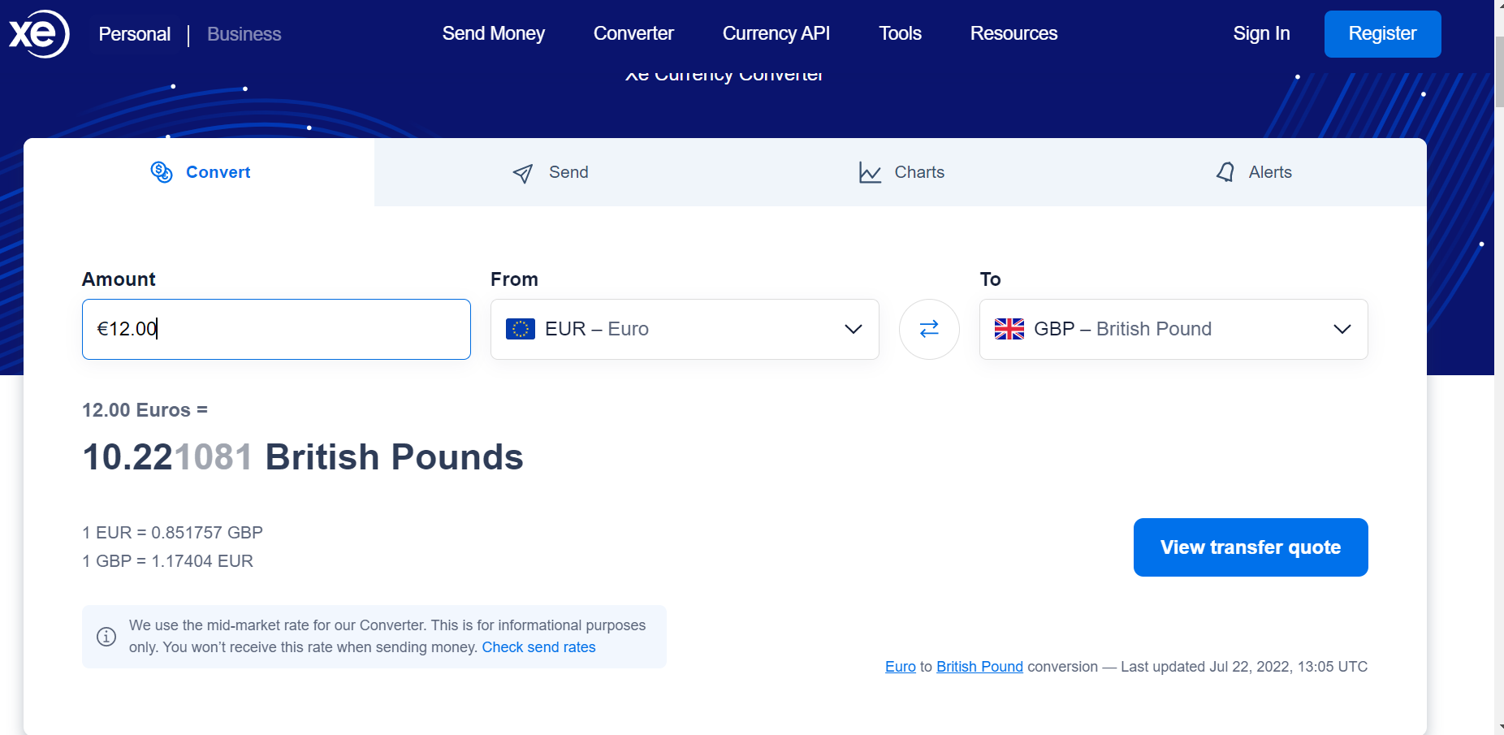

Here in the code, I have hard-coded values for the amount and to and from currency because as of now we are not using any data-driven approach for the test case.

So, in order to check the currency conversion for any set of amount and currencies, only three values need to be changed in the code:

1. // Amount to convert

driver.findElement(By.*cssSelector*("#amount")).sendKeys(String.*valueOf*(12));

1. // From Currency

driver.findElement(By.*cssSelector*("#midmarketFromCurrency")).sendKeys("EUR");

1. // To Currency

driver.findElement(By.*cssSelector*("#midmarketToCurrency")).sendKeys("GBP");

**Test Result:**

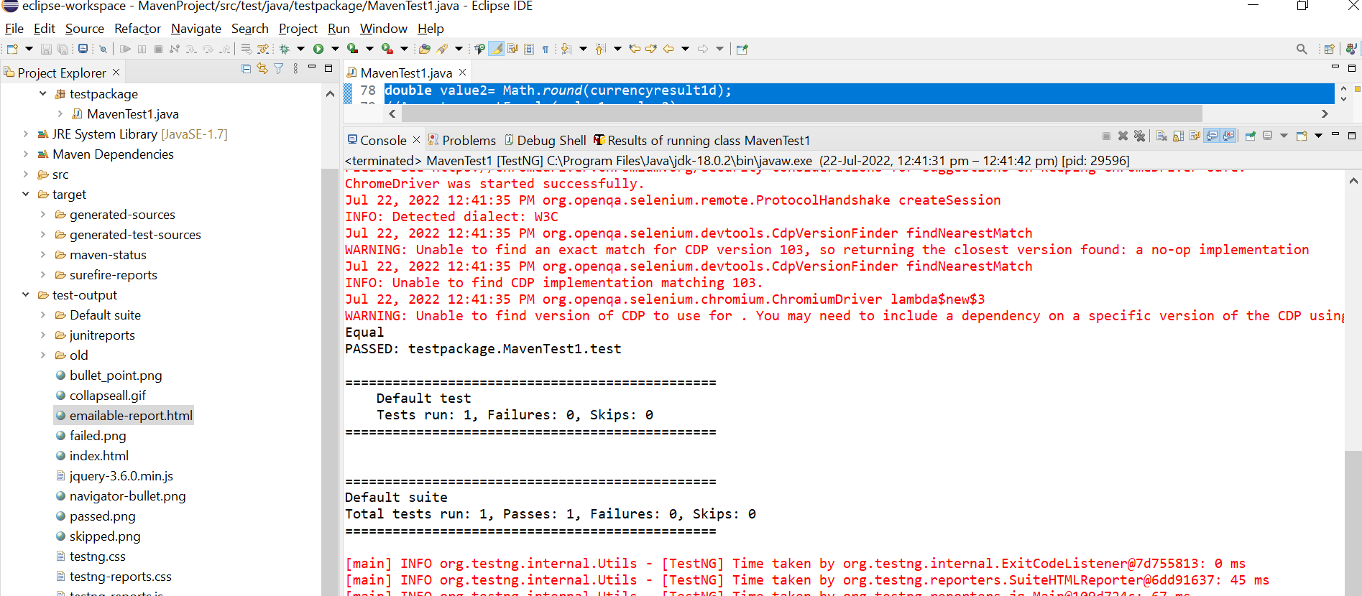

**Test Report:**

